Global Olympic Sports Performance Analysis
Project documentation: step-by-step development procedure
Prepared by: Mahi Garg | Tools: Tableau Public, Python (Flask), VS Code, GitHub
GitHub repository: https://github.com/mahi2305-byte/olympic-tableau-project
Tableau Public workbook: https://public.tableau.com/views/olympic_17926585026240/OlympicStory?:language=en-US&:sid=&:redirect=auth&:display_count=n&:origin=viz_share_link
Demo video: https://drive.google.com/file/d/1n2VJ9DAsfdBM-hvQuxqlun1mplrgy8hI/view?usp=sharing

1. Project overview and objectives
The Olympic Games are a global platform where nations compete to show their sporting strength. Success depends not only on athletes but also on sports infrastructure, athlete development programmes and investment. This project analyses Summer and Winter Olympic data from 1992 to 2026 (18 Games) using Tableau dashboards and a story, and presents the results on a web page built with Flask.
Objectives:
- Analyse medal achievements across 60 nations.
- Study athlete participation trends over time.
- Compare regional performance and medal efficiency.
- Find which sport categories give the best medal return per athlete.
- Study the relationship between sports investment level and medal outcomes.
- Show how host nations perform at home.
Intended users (from the project scenarios):
- A National Olympic Committee performance strategist who decides which sport categories to invest in.
- An investment analyst at an international funding agency who compares investment with medal results by country and region.
- A broadcast data journalist who needs trends, host-nation stories and regional narratives.
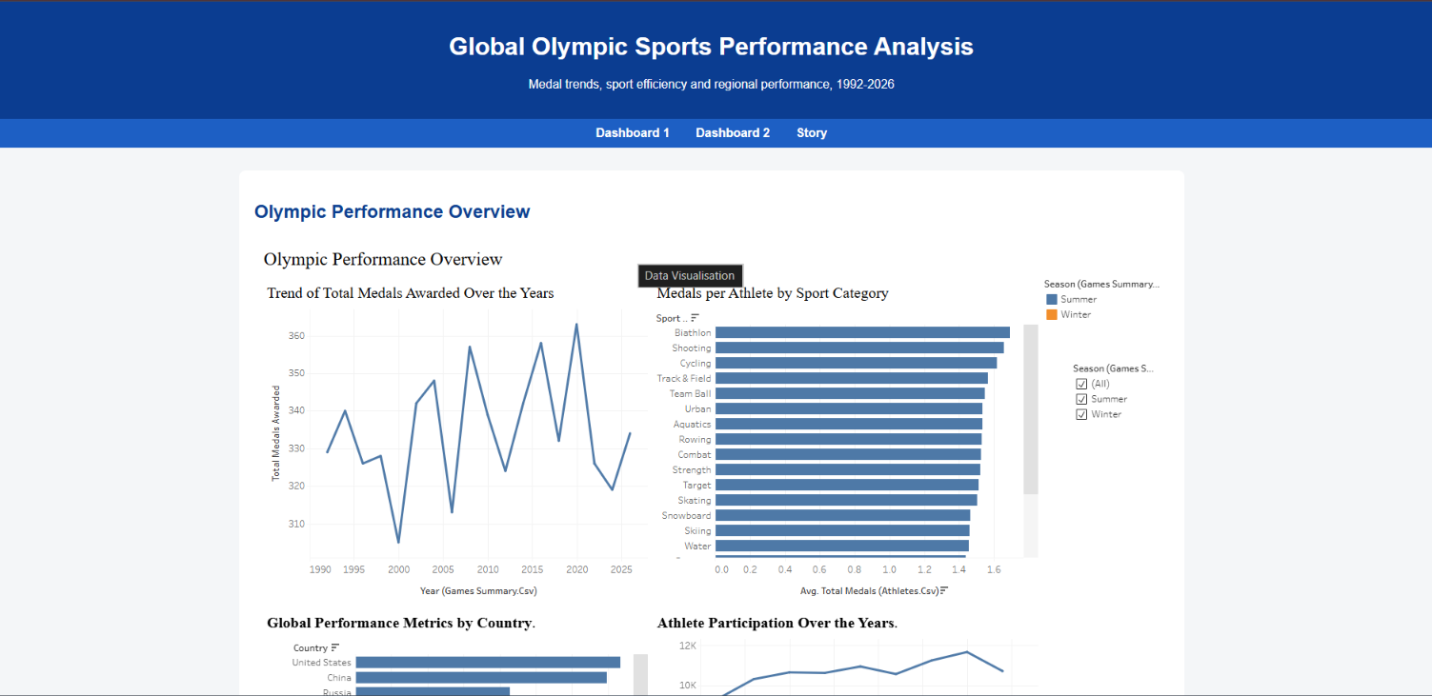

2. Technical architecture and tools
Component | Tool
Data sources | 4 CSV files (also kept as Excel files in the repository)
Data connection, visualisation, dashboards, story | Tableau Public Desktop
Publishing | Tableau Public (embed codes)
Web integration | Python 3 with Flask, edited in VS Code
Version control | Git and GitHub
System used: Windows 10/11, web browser (Chrome), VS Code, Python virtual environment (venv) for Flask.

3. Data collection
Four datasets were collected and stored in the project folder.
Dataset | Rows | Columns | What one row means
alltime_country_rankings | 60 | 13 | One country: total gold, silver, bronze and overall medals, region
athletes | 8,000 | 26 | One athlete: country, region, season, sport, sport category, total medals, and other athlete details
games_summary | 18 | 10 | One Olympic Games: year, season, host city and country, total medals awarded, total athletes, nations
medal_results | 910 | 21 | One country in one Games: medals, athletes sent, medal efficiency percentage, sports investment level, host nation flag, region
Checks on the files showed no missing values and no duplicate rows. The data covers 60 countries, 50 sports grouped into 21 sport categories, and 18 Games from 1992 to 2026.

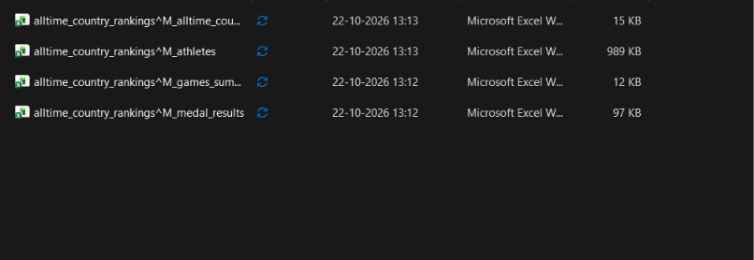

4. Connecting the data to Tableau
Steps followed:
- Opened Tableau Public and chose Connect → Text file.
- Opened the medal_results file first, because it is the central table.
- Dragged the other three files from the Files list onto the canvas, one at a time.
- Created a relationship for each file (relationships keep each table's own row count, so totals are not inflated):
Table | Connected to | Matching fields
alltime_country_rankings | medal_results | Noc Code = Noc Code (Medal Results)
athletes | medal_results | Noc Code (Athletes) = Noc Code (Medal Results)
games_summary | medal_results | Year (Games Summary) = Year
- Checked that all warning icons on the relationship lines had disappeared.
- Saved the workbook to Tableau Public under the name "olympic".
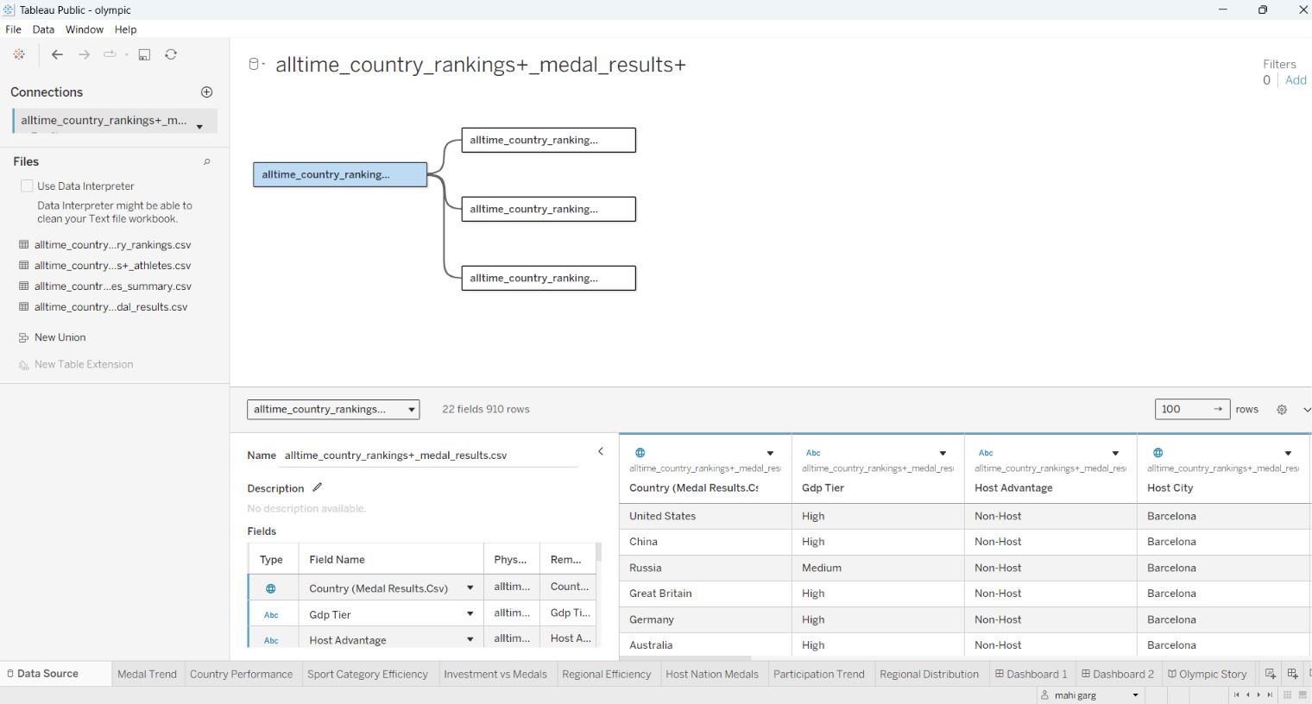

5. Data preparation
- Checked the data in the Data Source grid for nulls, duplicates and data types.
- Set Year as a dimension on charts that need one point per Games, so Tableau does not add the years together.
- Used average rather than sum for percentage and per-athlete measures, because adding percentages gives a meaningless result.
- Applied a filter on Host Nation = 1 for the host-nation chart.
- Created two calculated fields:
Calculated field | Formula | Purpose
Medals per Athlete | SUM([Total Medals]) / SUM([Athletes Sent]) | Compares medal return per athlete sent, by country
Host Status | IF [Host Nation] = 1 THEN "Host" ELSE "Non-Host" END | Labels each row as Host or Non-Host
The donut chart also uses helper fields (MIN(0)) to create the dual-axis hole.
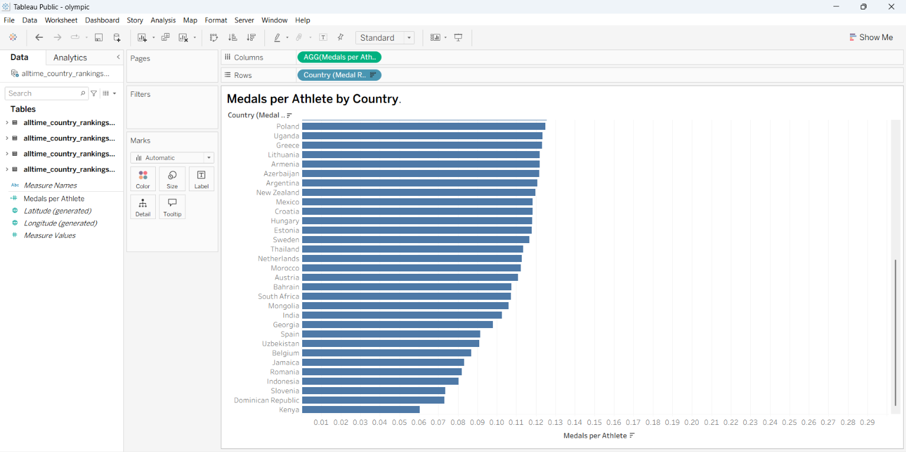

6. Visualisations
Nine charts were built. Each is described with its construction and main insight.

6.1 Trend of Total Medals Awarded Over the Years (line chart)
Built from games_summary: Year (dimension) on Columns, Total Medals Awarded on Rows.
Insight: total medals awarded across the Games moved between a low of 305 in 2000 and a peak of 363 in 2020, and reached 334 in 2026. The totals swing from one Games to the next rather than rising steadily.
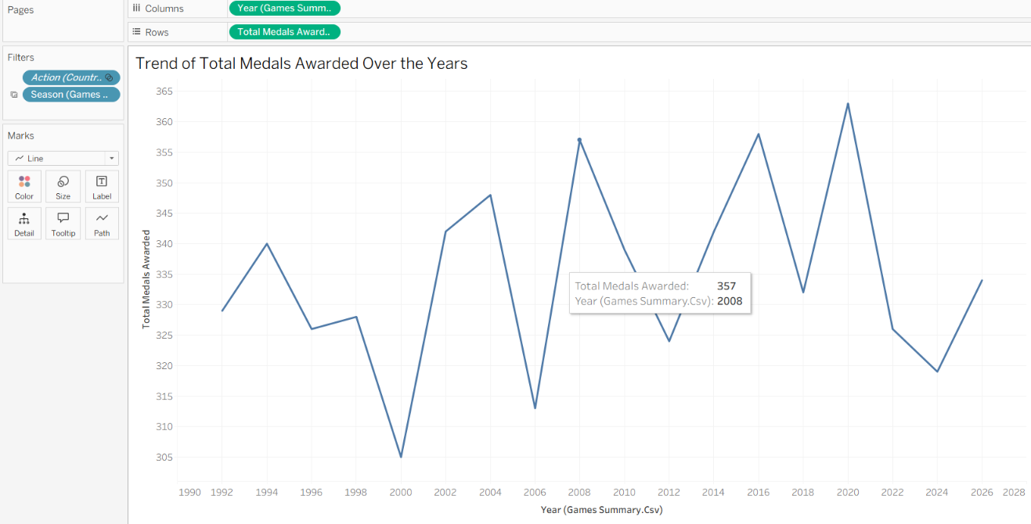

6.2 Global Performance Metrics by Country (horizontal bar chart)
Built from alltime_country_rankings: Country on Rows, Total Medals on Columns, sorted in descending order.
Insight: the United States leads with 735 medals, followed by China with 696. Russia (about 429) and Great Britain (about 401) follow, and the remaining countries fall away quickly.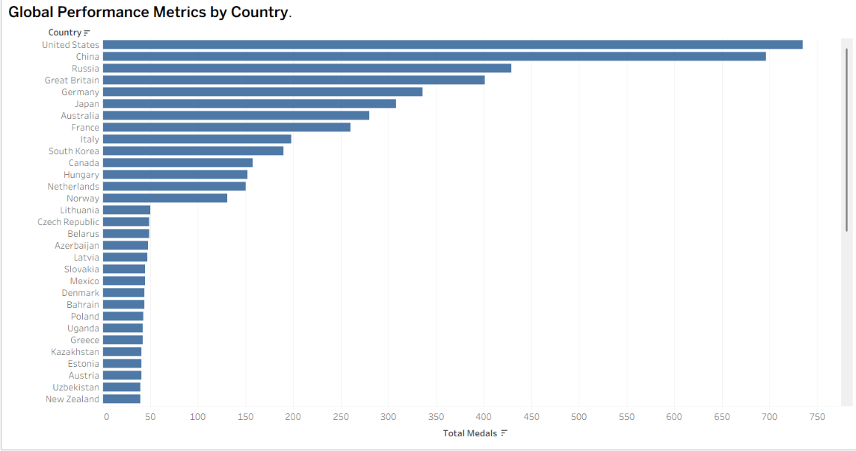

6.3 Average Medals per Athlete by Sport Category (horizontal bar chart)
Built from athletes: Sport Category on Rows, average of athletes' total medals on Columns, sorted in descending order. There are 21 sport categories.
Insight: Biathlon (about 1.69), Shooting (about 1.66) and Cycling (about 1.62) give the highest medal return per athlete, while Sliding (about 1.31) and Gymnastics are lowest. The spread between categories is small, so returns are fairly even across categories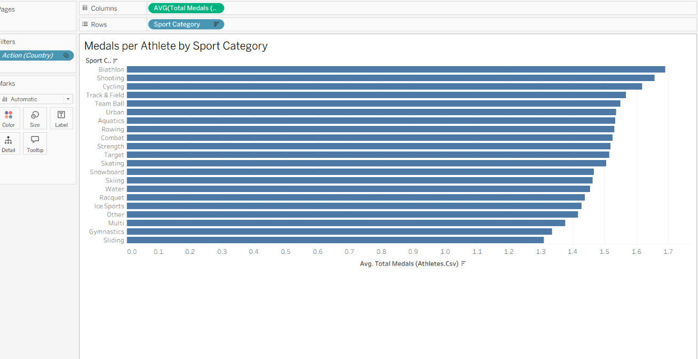

6.4 Global Sports Investment vs. Medal Performance (bubble chart)
Built from medal_results: Athletes Sent on Columns, Total Medals on Rows, Country on Detail, average Medal Efficiency Pct as bubble size, Sports Investment (High, Medium, Low) as colour. There are 60 bubbles, one per country.
Insight: medals rise with the number of athletes sent. The United States and China sit far at the top right with over 5,000 athletes each, and most countries cluster at the lower left with small teams. Each country keeps one investment level across all Games: 34 are Medium, 14 are Low and 12 are High.
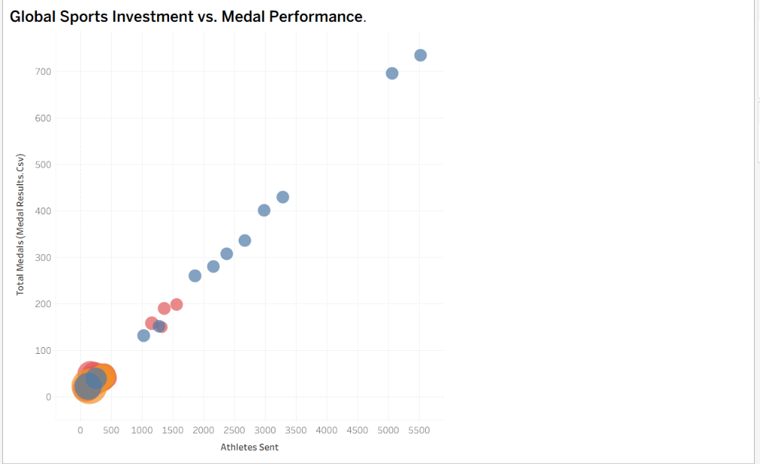

6.5 Average Medal Efficiency Percentage by Region (pie chart)
Built from medal_results: Region on colour, average Medal Efficiency Pct on angle.
Region | Average efficiency %
South America | 49.64
Europe/Asia | 45.98
Africa | 42.80
Asia | 32.96
Oceania | 27.79
Europe | 27.48
North America | 27.46
Insight: South America and Europe/Asia are the most efficient regions. These are good candidates for further support from a funding agency.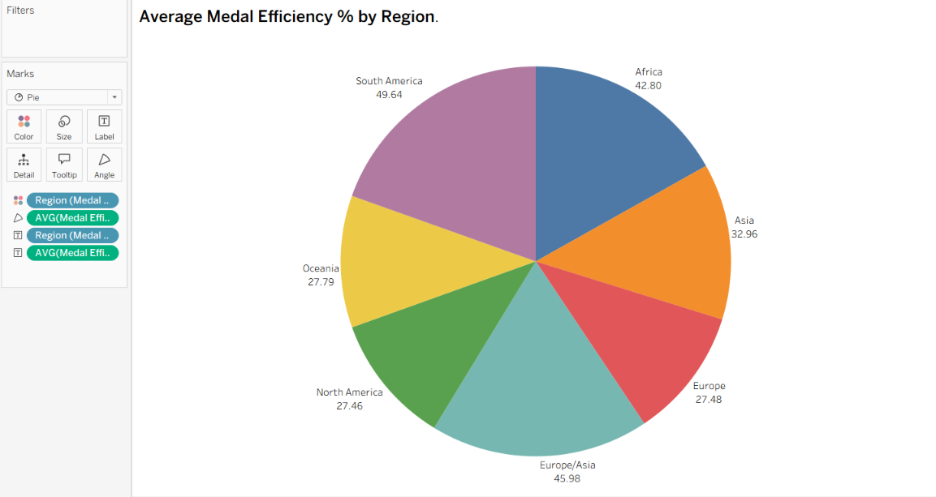

6.6 Medal Totals Across Olympic Hosts (bar chart)
Built from medal_results with a filter Host Nation = 1, so only rows where the country was the host are counted. 13 host countries appear.
Insight: China (118) and the United States (116) win the most medals when hosting, followed by Japan (51) and Russia (39). Smaller hosts such as Greece and Spain win far fewer.
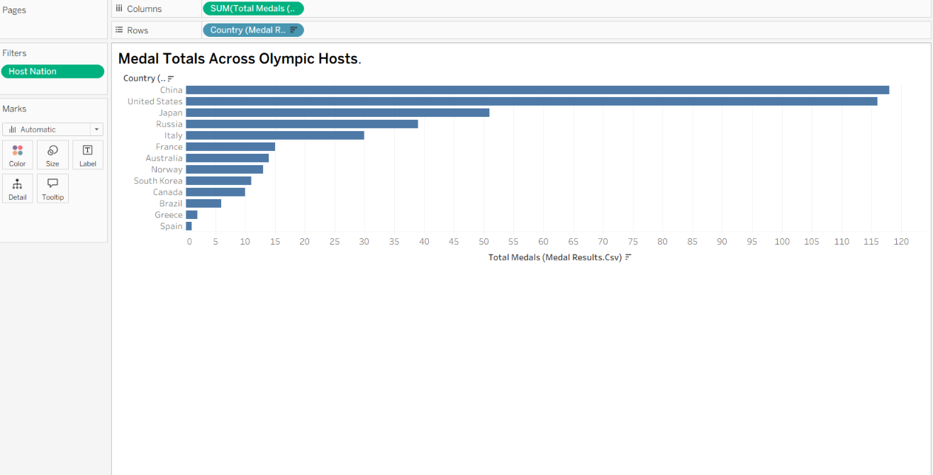

6.7 Athlete Participation Over the Years (line chart by season)
Built from games_summary: Year on Columns, Total Athletes on Rows, Season on colour. The total across all 18 Games is 119,120 athlete entries.
Insight: Summer Games send about 9,000 to 11,000 athletes, Winter Games about 2,000 to 3,000. Both lines rise slowly over time.
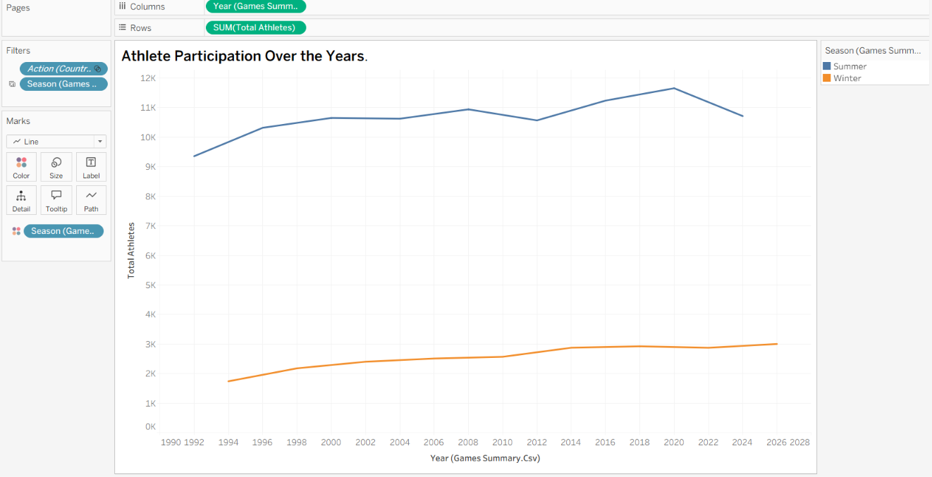

6.8 Regional Medal Efficiency and Distribution (donut chart)
Built from medal_results: Region on colour and Total Medals on angle, with a dual-axis white circle to make the hole.Insight: Europe holds the largest share of medals, followed by Asia and North America 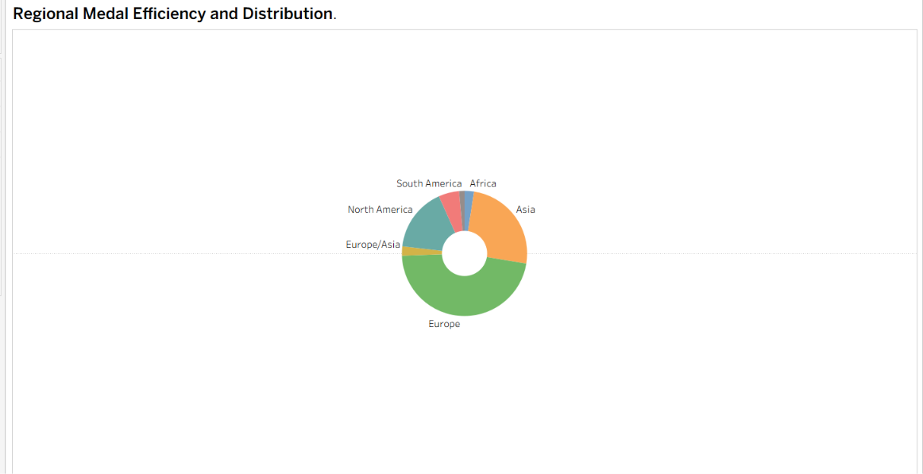

6.9 Medals per Athlete by Country (bar chart using a calculated field)
Built from the Medals per Athlete calculated field with Country on Rows.
Insight: smaller teams can have a high medal return per athlete. The Czech Republic ranks first (about 0.29 medals per athlete sent), followed by Latvia, Brazil and Cuba. This view is different from the total-medals ranking and rewards efficiency rather than size.
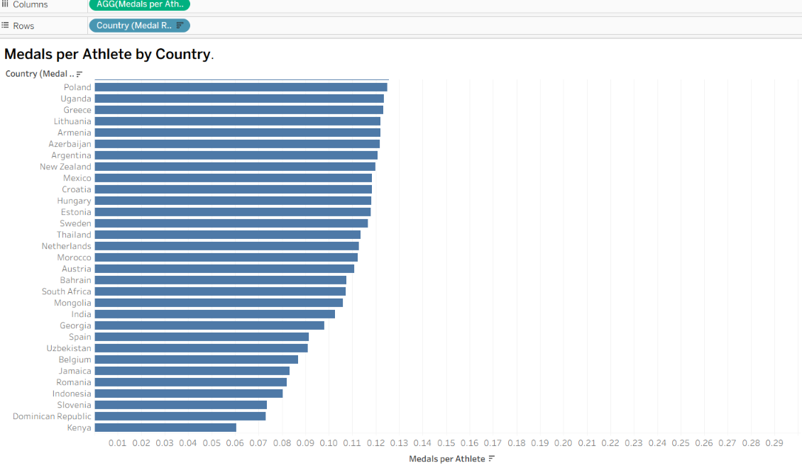
Note on figures: all values above come from the datasets used in this project. Some sample numbers quoted in the project scenarios were produced with different calculations, so a few figures may differ slightly.

7. Dashboards
The dashboard size was set to Automatic so that it fits different screen sizes.

Dashboard 1: Olympic Performance Overview
Contains Medal Trend, Medals per Athlete by Sport Category, Global Performance Metrics by Country and Athlete Participation Over the Years. A Season filter (Summer/Winter) is included, and the country chart works as a filter.
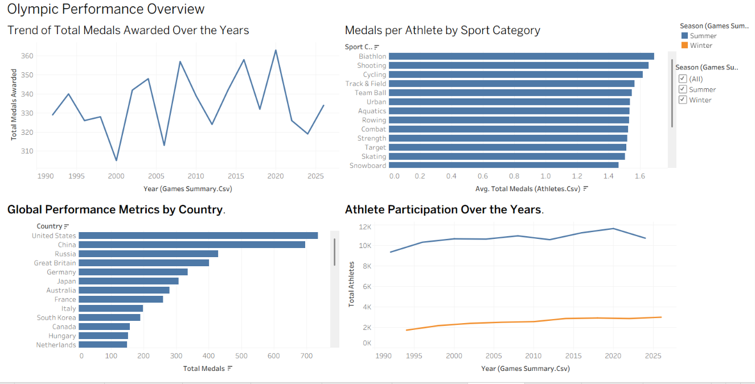

Dashboard 2: Olympic Performance and Regional Efficiency Dashboard
Contains Global Sports Investment vs. Medal Performance, Average Medal Efficiency by Region, Medal Totals Across Olympic Hosts and Regional Medal Efficiency and Distribution.
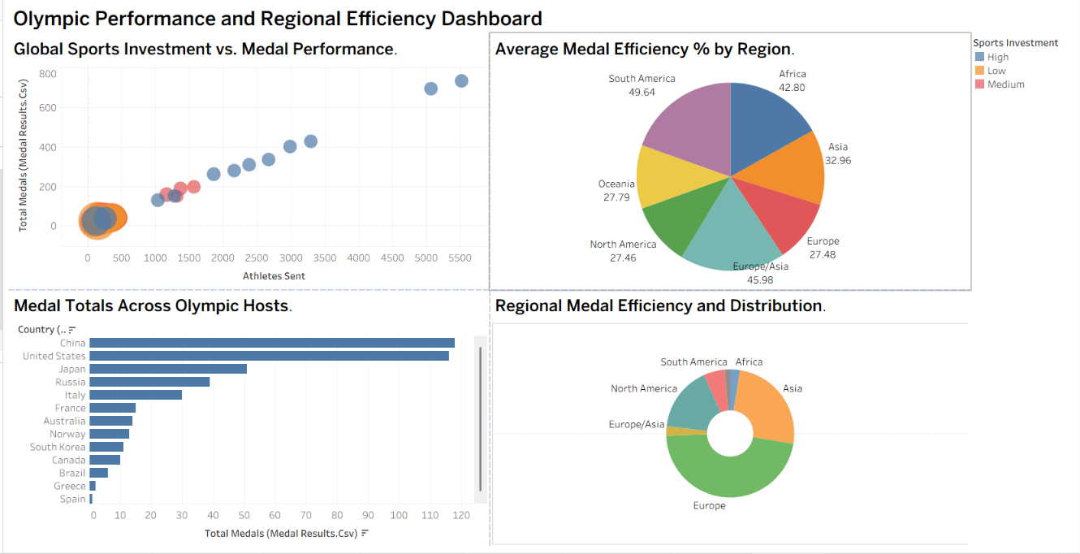

8. Story
The story "Olympic Story" has six scenes, each with a caption:

Scene | View | Message
1 | Medal Trend | Total medals awarded swung from 305 in 2000 to 363 in 2020
2 | Country Performance | The United States (735) and China (696) lead all-time totals
3 | Sport Category Efficiency | Biathlon, Shooting and Cycling give the highest return per athlete
4 | Investment vs Medals | Countries with more athletes win more medals; bubble size shows efficiency
5 | Regional Efficiency | South America (49.64%) and Europe/Asia (45.98%) lead on efficiency
6 | Host Nation Medals | Host nations such as China and the United States win many medals at home

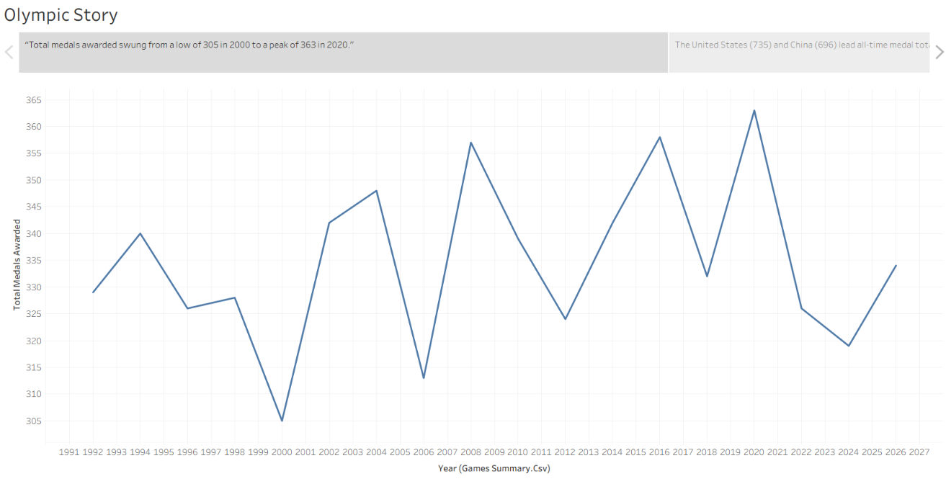
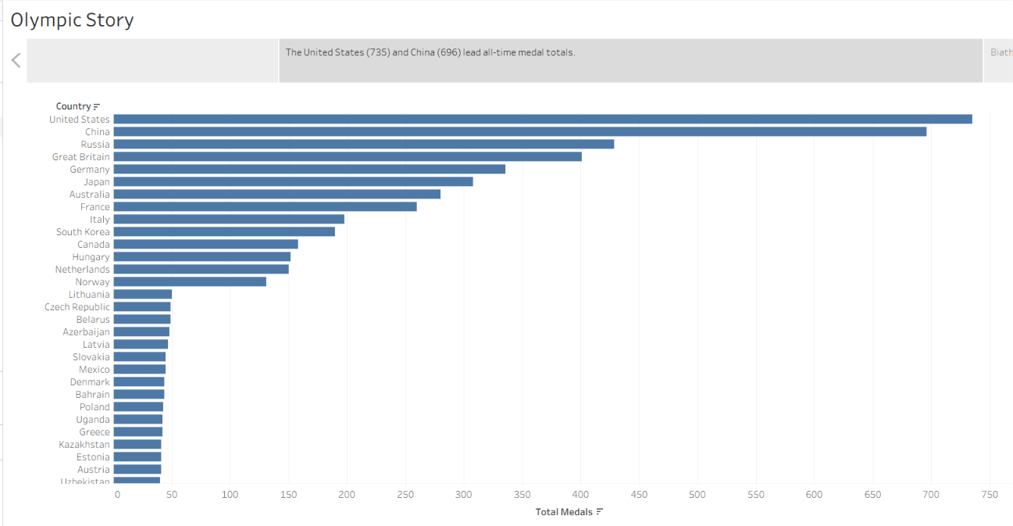
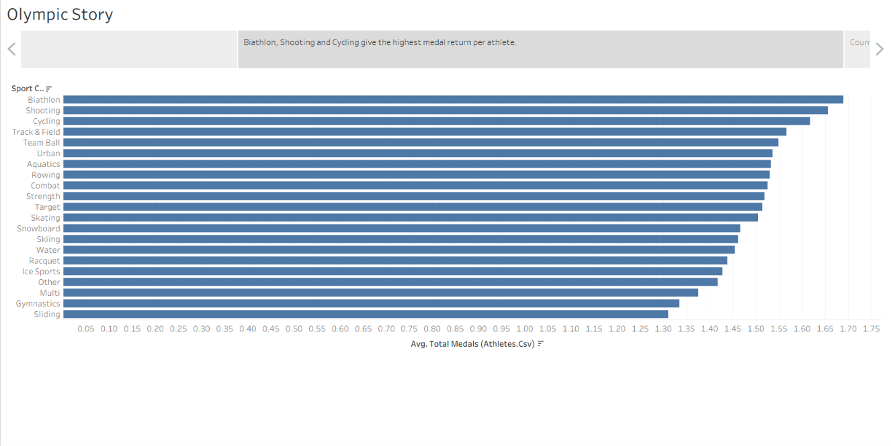
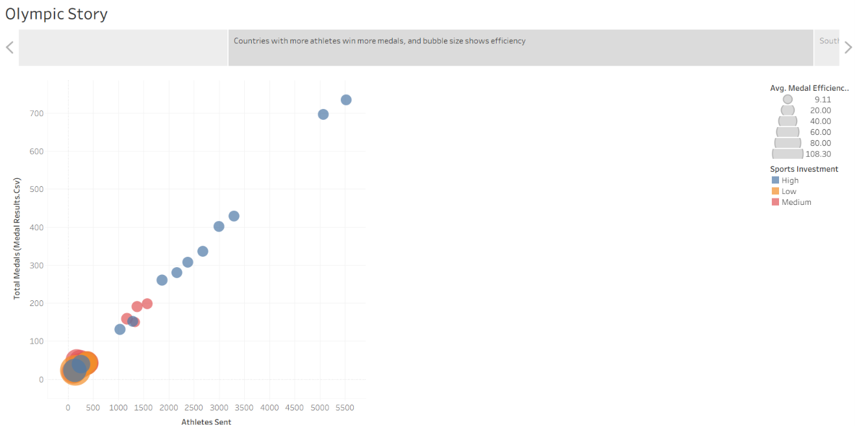
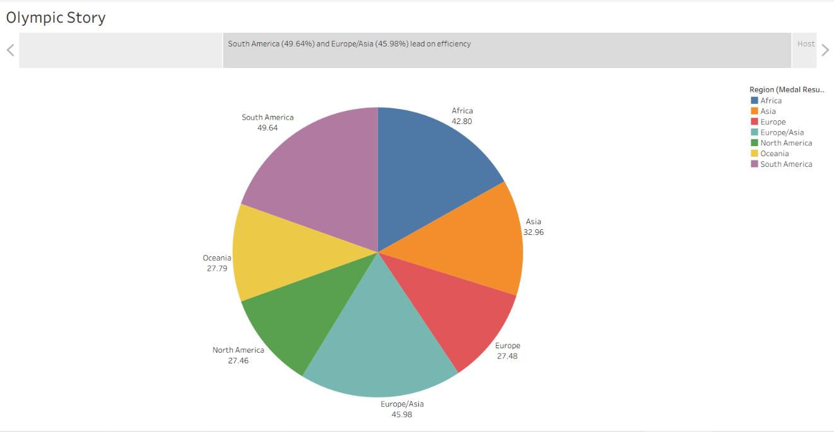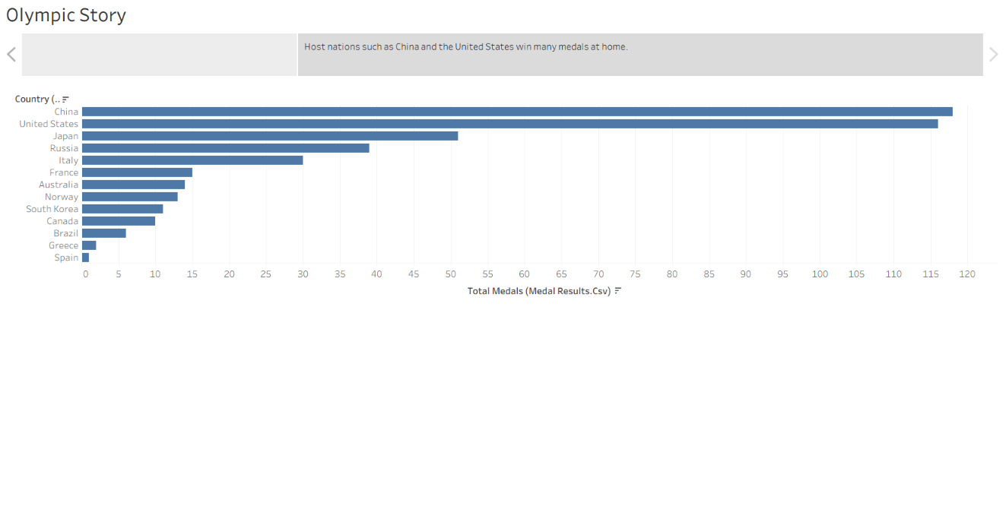

9. Performance testing
Item | Result
Amount of data loaded | 4 files, 8,988 rows in total (athletes 8,000; medal_results 910; country_rankings 60; games_summary 18)
Utilisation of data filters | Host Nation filter on the host chart; Season filter on Dashboard 1; "Use as Filter" on the country chart
Number of calculation fields | 2 (Medals per Athlete, Host Status), plus helper fields for the donut
Number of visualisations | 9 charts, 2 dashboards, 1 story with 6 scenes
Each dashboard loaded without delay on the test computer.

10. Web integration with Flask

Steps
- Published the workbook to Tableau Public and turned on "Show sheets as tabs".
- Copied the embed code of Dashboard 1, Dashboard 2 and the Olympic Story from the Share option, and saved them in embed_codes.txt.
- Created a Python virtual environment in VS Code and installed Flask inside it.
- Created the folder structure:
flask_app/
app.py
templates/
index.html
- Wrote app.py, which serves the page:
from flask import Flask, render_template
app = Flask(__name__)
@app.route("/")
def home():
return render_template("index.html")
if __name__ == "__main__":
app.run(debug=True)
- Built index.html with a header, a navigation bar (Dashboard 1, Dashboard 2, Story) and three sections, each containing one Tableau embed code. The embed settings were changed so that tabs are hidden (tabs = no), and CSS makes the embedded views fill the page width at a height of 950 pixels.
- Ran the app with python app.py from the flask_app folder and opened http://127.0.0.1:5000.

Problems met and how they were fixed
- Flask was not recognised in VS Code: a virtual environment was created and Flask installed inside it.
- The app could not find app.py: the terminal was in the wrong folder, so the command was run from inside flask_app.
- Dashboard 2 did not appear: the Dashboard 1 script was incomplete (missing closing tag), so the rest of the page was read as script. Completing the script fixed it.

11. Version control with GitHub
The project is stored in the repository mahi2305-byte/olympic-tableau-project. It contains the four datasets, the Tableau workbook (olympic.twbx), the flask_app folder, embed_codes.txt and a README with run instructions. The virtual environment folder is not uploaded.
[Insert screenshot: GitHub repository page]
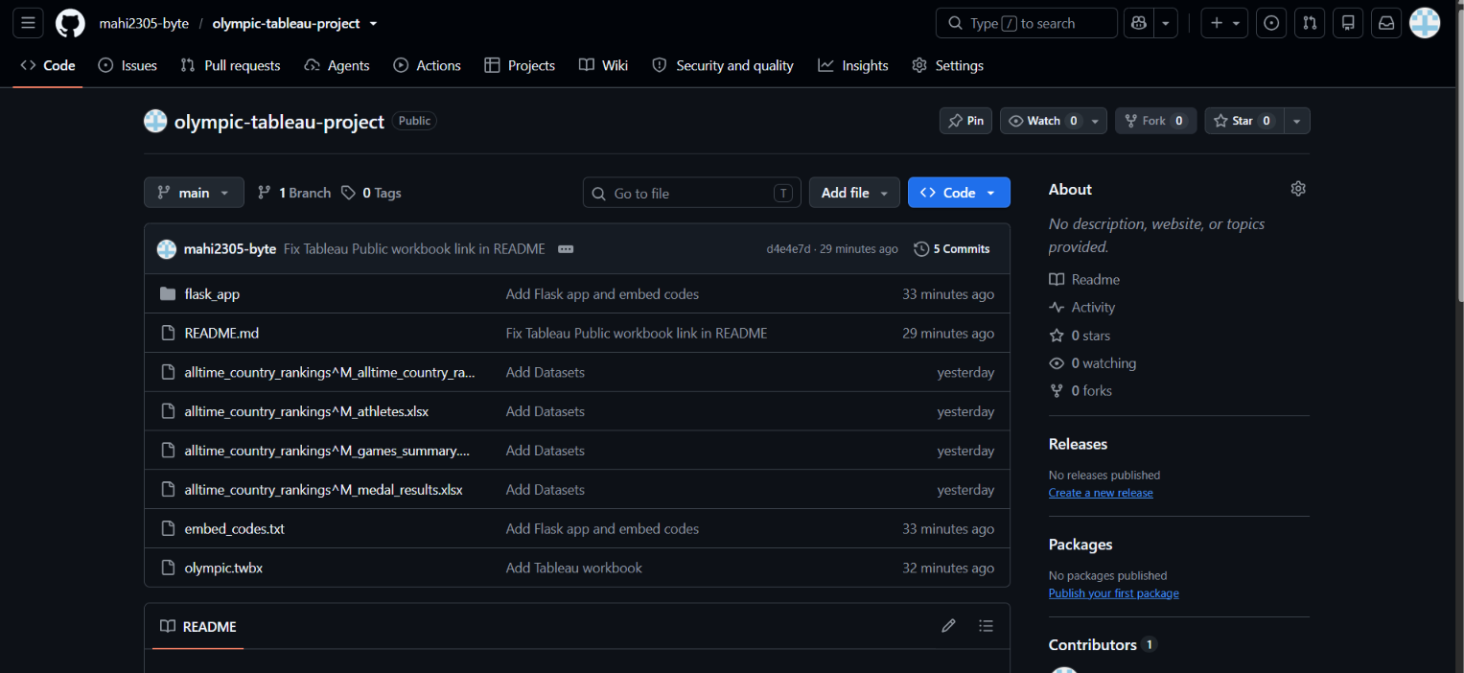

12. Conclusion and key insights
- Total medals awarded per Games stayed between 305 and 363, with no steady upward trend.
- The United States (735) and China (696) lead all-time medal totals, and they also win the most medals as hosts (116 and 118).
- Per athlete, Biathlon, Shooting and Cycling give the best medal return, and the gap between categories is small.
- South America (49.64%) and Europe/Asia (45.98%) are the most efficient regions, so they are good targets for additional support.
- Medal totals grow with team size, but smaller teams such as the Czech Republic and Latvia achieve a high medal return per athlete.
- Summer Games involve about four times as many athletes as Winter Games.
How stakeholders can use the results:
- National committees can invest in sport categories with a high medal return per athlete and review low-return ones.
- Funding agencies can use the efficiency view by region and the investment bubble chart to find high-potential regions.
- Journalists can use the trend, host-nation and regional views to tell the story of Olympic competition from 1992 to 2026.
Possible future work: add year filters to every chart, add more per-sport detail, and host the Flask app online.

